**Make a simple dashboard and show columns, bar charts, line charts, and area charts.**

[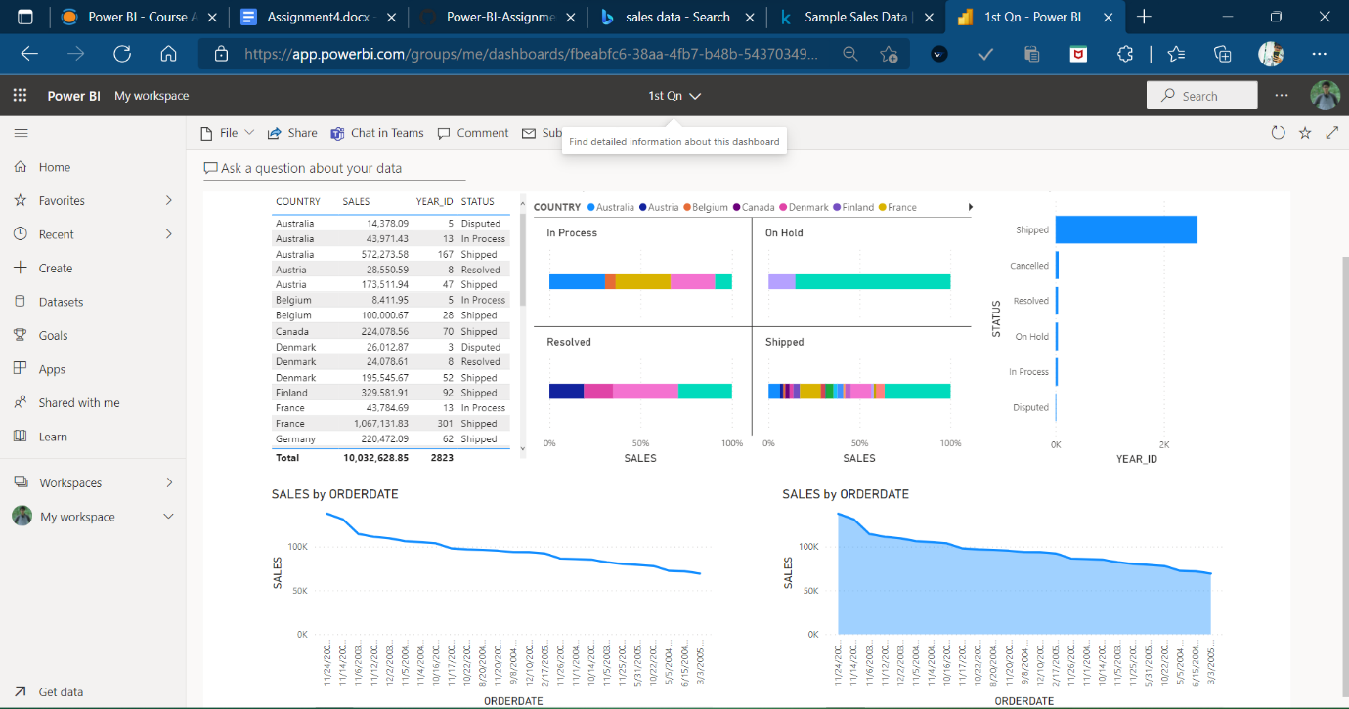](https://user-images.githubusercontent.com/88320437/153740443-a3307047-ac20-405a-adad-64ccd586e582.png)

**Make a simple dashboard and show combination chart, Scatter chart, Shape chart, and Treemap chart.**

[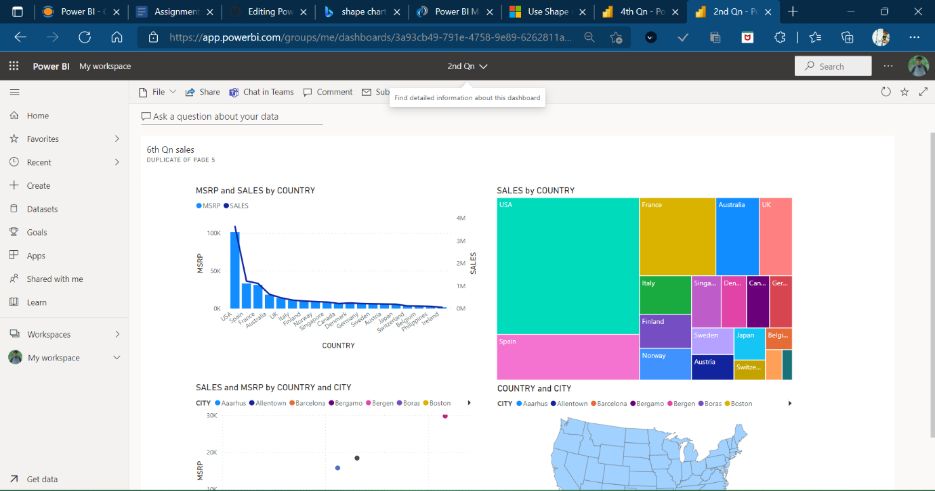](https://user-images.githubusercontent.com/88320437/153740452-343b1272-b262-4e8c-b41e-14d4d20c72cb.png)

**Make a dashboard and show 2 maps visualization i.e. basic map and filler maps**

[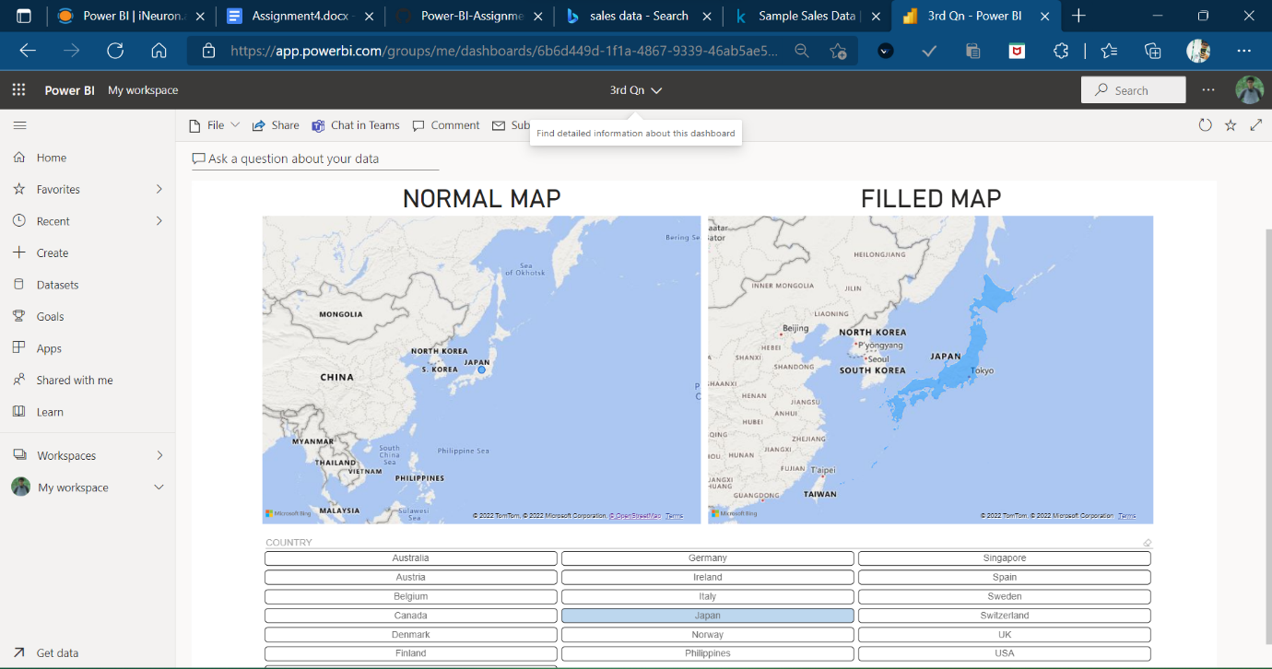](https://user-images.githubusercontent.com/88320437/153740466-6f3e6c98-c68a-4d81-ba91-df9cbac12d0f.png)

**Create a report which has:**

* Bar chart
* Card visualizations
* Combo chart visualizations
* Matrix visualizations
* Column chart visualizations guide: Sales data can be used

[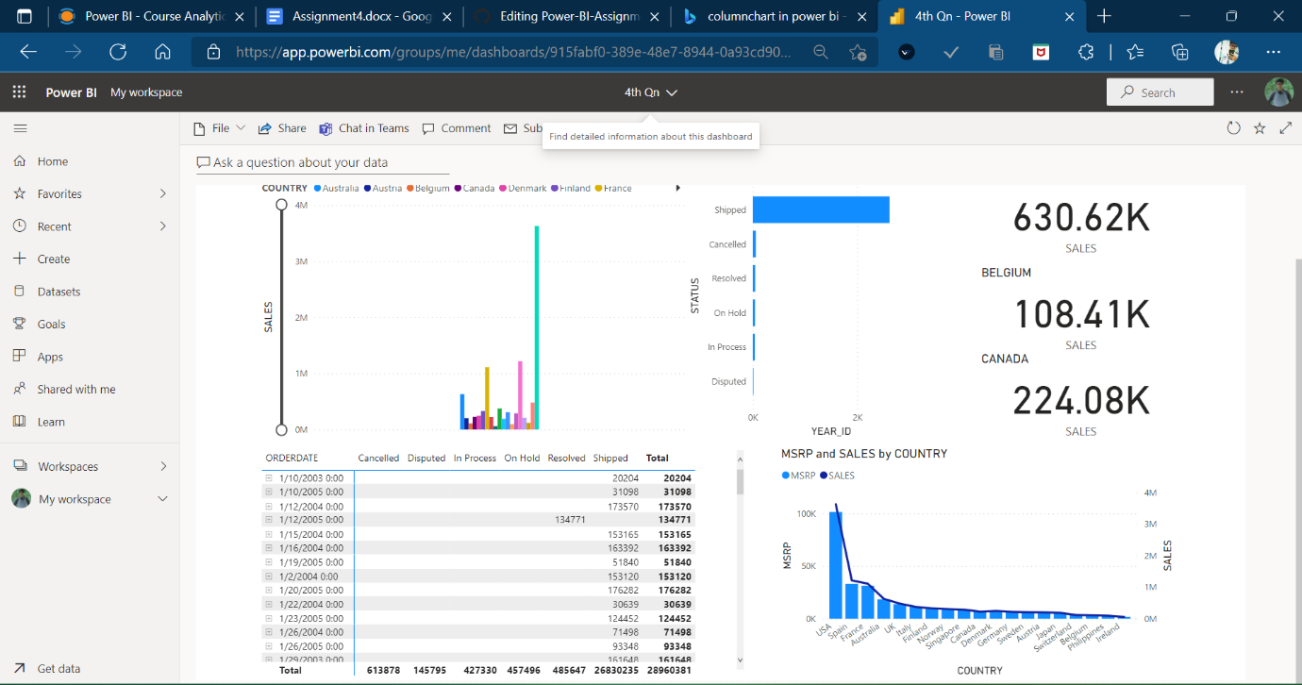](https://user-images.githubusercontent.com/88320437/153740484-8c26c43e-04dd-48d8-8cf4-9928261be6ae.png)

**Make a report to analyze product sales using treemap visualization.**

[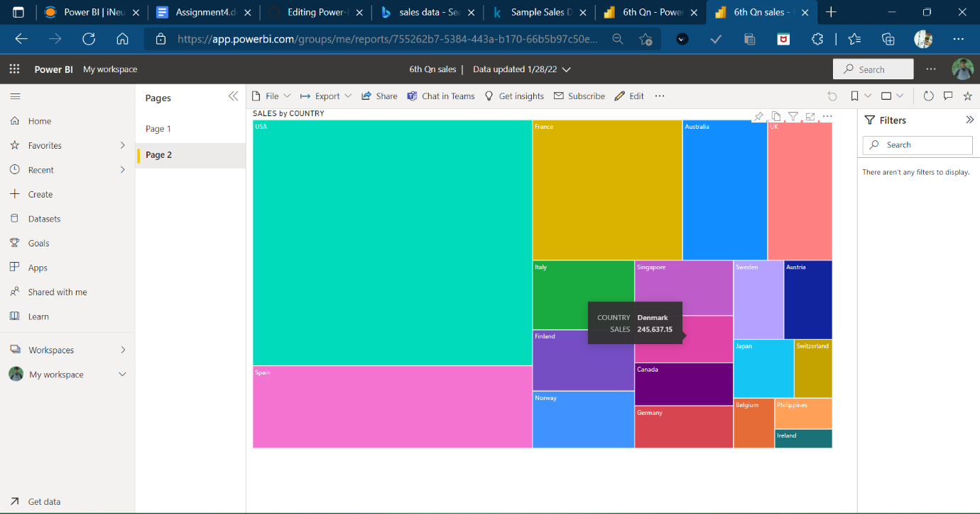](https://user-images.githubusercontent.com/88320437/153740501-607e0d5c-a434-4254-8bde-7cd28922d9ee.png)

**Make a dashboard on sales data (Minimum 4 tiles).**

[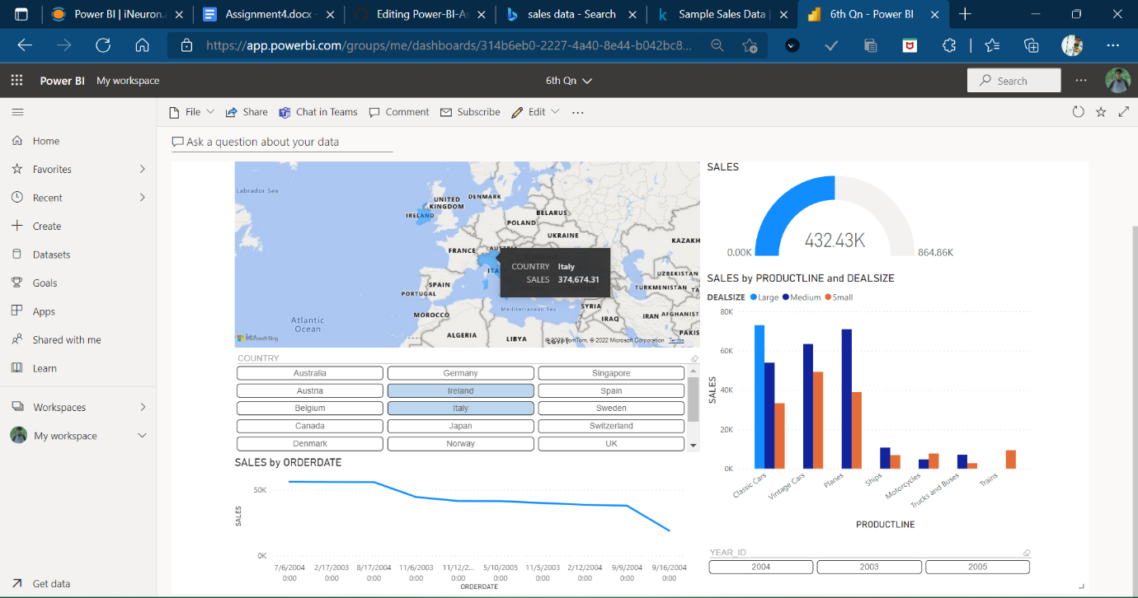](https://user-images.githubusercontent.com/88320437/153740519-d98ec65f-5d11-4ceb-97a1-b835224b7f9f.png)